6. To perform simple addition using embedded components in Lab view software.

**AIM**

To build a VI that performs addition of two numbers and displays the result using LABVIEW.

**ALGORITHM**

1. Open labview software
2. Open blank VI.
3. Right click on the front panel window to open the control palette.
4. Insert the numeric controls as a input from the control palette.
5. Right click on the block diagram to open the function palette.
6. Add the Adder tool from the numeric sub palette from the function palette.
7. Insert the numeric indicator as an output from the control palette.
8. Connect all the terminals in the block diagram window.
9. Enter inputs in the front panel and click run to display the result.

**Diagram**

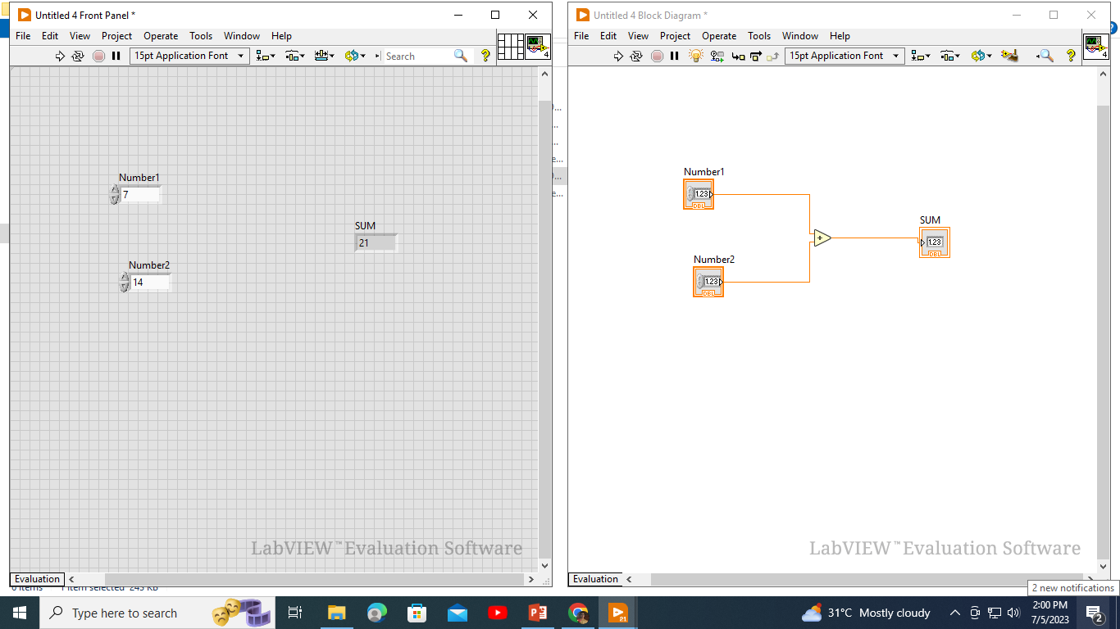

**RESULT**

Thus, a VI performs addition operation and displays the result using LABVIEW.